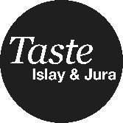
Taste Islay & Jura
Eating, Drinking and Activity Experiences
Taste Islay and Jura is a new 3-day food, drink and foraging festival that will take place on Islay and Jura September 20th – 22nd September.
We keen that all businesses get involved in the event and are asking you to make a commitment for what your business could offer to create a ‘whole community’ approach to the festival.
For example, this might be a special menu for the weekend using only local produce, you might be able to offer an adventure activity relevant to food or drink, put on a special tour, host your own event. Organisers are seeking to collate ideas from businesses looking to take part. We will then send you a toolkit which will include logo and promotion details so that you can make the most of this event for your business and the festival itself.
Name
Name of Business
Business address
Phone Number
E mail address

Are you a member of the Islay & Jura Tourism and Marketing Group?  Note: participants are required to be members of this group – email bonniewoodislay@islayjura.com for details. | Yes / No
How would you describe your business?
E.g. Hotel, Restaurant, Distillery, Food Producer, Activity Provider etc.
Please describe what your business can offer during the festival event.
Note: this is something at your business would organise, manage and receive income from. It would be promoted under the banner of ‘Taste Islay & Jura’ during the festival weekend.
Please complete the above form, and return it to: Bonnie Wood, Sean Sgoil, The Oa, Isle of Islay, PA42 7AX. Or email bonniewoodislay@islayjura.com
Data protection
The Islay and Jura Tourism and Marketing Group take your privacy seriously and will only use your personal information to inform you of Islay & Jura Tourism & Marketing Group and Taste Islay and Jura related matters. Our full privacy statement can be found at www.islayjura.com/privacy.php
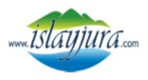
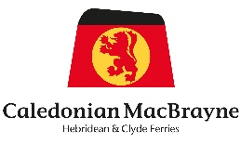
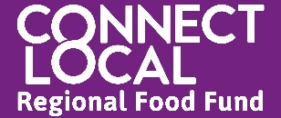
Supported by Connect Local Regional Food Fund, Calmac Ferries Ltd & Argyll & the Isles Tourism Co-operative

